|  |  |
| --- | --- |
| **Parish name** |  |
| **Program/activity/event name** |  |
| **Goals and objectives** |  |
| **Description of the physical/online space** |  |
| **Description of program/activity/event**   * Overview * Participants (age, gender, ability etc.) * Time and day * Frequency e.g. weekly, annually, one-off etc. * Duration |  |
| **Responsible personnel involved**   * Internal * External |  |
| **Additional information** |  |
| **Next review date**  ***(include a date when the plan will be reviewed and who is responsible for the review, noting that if there are any critical incidents the plan will be reviewed immediately).*** |  |

RISK ASSESSMENT

RISK RATING MATRIX

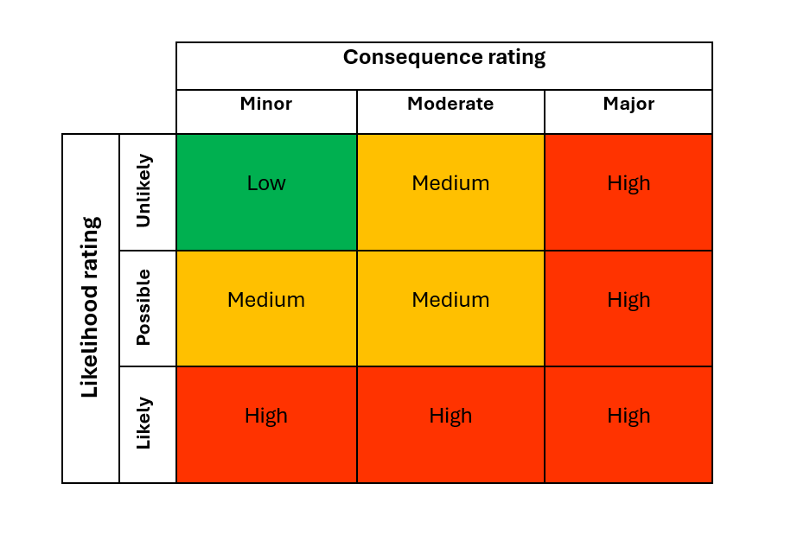

|  |  |  |  |  |  |  |
| --- | --- | --- | --- | --- | --- | --- |
| **Personnel** | | | | | | |
| **Current Control Measures** | | | **Action plan** | | | |
| **Risk description** | **Risk controls: what is currently in place?** | **Level of risk**  **(‘Consequence Rating’ x ‘Likelihood Rating’)** | **Risk treatment actions** | **Resources required** | **Completion date** | **Accountability** |
|  |  |  |  |  |  |  |
|  |  |  |  |  |  |  |

|  |  |  |  |  |  |  |
| --- | --- | --- | --- | --- | --- | --- |
| **Participants** | | | | | | |
| **Current Control Measures** | | | **Action plan** | | | |
| **Risk description** | **Risk controls: what is currently in place?** | **Level of risk**  **(‘Consequence Rating’ x ‘Likelihood Rating’)** | **Risk treatment actions** | **Resources required** | **Completion date** | **Accountability** |
|  |  |  |  |  |  |  |
|  |  |  |  |  |  |  |

|  |  |  |  |  |  |  |
| --- | --- | --- | --- | --- | --- | --- |
| **Practices** | | | | | | |
|  | | | | | | |
| **Current Control Measures** | | | **Action plan** | | | |
| **Risk description** | **Risk controls: what is currently in place?** | **Level of risk**  **(‘Consequence Rating’ x ‘Likelihood Rating’)** | **Risk treatment actions** | **Resources required** | **Completion date** | **Accountability** |
|  |  |  |  |  |  |  |
|  |  |  |  |  |  |  |

|  |  |  |  |  |  |  |
| --- | --- | --- | --- | --- | --- | --- |
| **Places** | | | | | | |
| **Current Control Measures** | | | **Action plan** | | | |
| **Risk description** | **Risk controls: what is currently in place?** | **Level of risk**  **(‘Consequence Rating’ x ‘Likelihood Rating’)** | **Risk treatment actions** | **Resources required** | **Completion date** | **Accountability** |
|  |  |  |  |  |  |  |
|  |  |  |  |  |  |  |